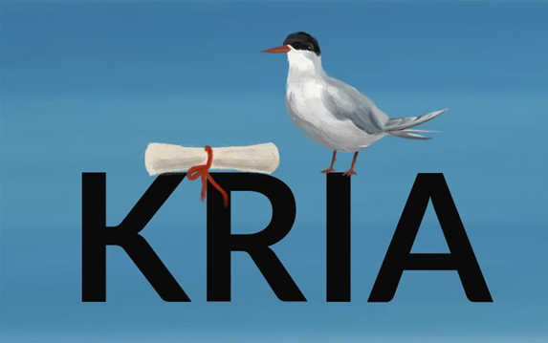

About of the project: KRIA The Icelandic Constitution Archive
In 2011, Iceland wrote its constitution using a uniquely and historically open process. It
reshaped the dialogue on how a population can harness technology, consensus
building, and civic engagement in reimagining its foundation. Unfortunately, the
material around this historical event is disappearing. KRIA is an interdisciplinary
initiative to preserve its evidence and make content widely accessible.
About the Internship:
The KRIA internship is an opportunity for students interested in library science,
Scandinavian studies, constitutional law, journalism, or civic movements. The
internship will be conducted remotely. Tasks will be performed independently on the
student's schedule. Students will meet on Zoom monthly with the Project Director and
internship team to discuss ideas and progress. All positions are remote. Therefore
applicants must have a computer and internet access. There are three types of
internship positions available. Additional opportunities are available for students fluent
in Icelandic. Please refer to the descriptions below.
Compensation:
The following internship positions are unpaid. Interns will be provided a letter of
recommendation, any necessary assessments, and a summary of work conducted at
the close of the internship.
Term:
Three months 5-10 hours a week. The internship program is flexible to students'
schedules and course requirements. We ask for a minimum commitment of 5 hours per
week. Extensions beyond the three-month term are available upon request. Please
discuss course credit arrangements with your instructor/department.
Opportunity 1. Content Analyst Internship: 7 positions available
This opportunity is excellent for students interested in digital humanities, political
science, civic engagement, and bottom-up constitutional processes.
Responsibilities:
● The student will review provided materials within the KRIA archive and identify
terminology/metadata to serve the public in accessing materials.
● Each intern will be assigned a multimedia collection to examine and label.
Qualifications:
● Ability to analyze multi-media content and produce summaries.
● Critical thinking (i.e., what search terms will be used to discover this material)
● Working knowledge of Google Spreadsheets
● Strong attention to detail and interest in the subject matter.
Opportunity 2. Media Internship: 3 positions
This opportunity is excellent for students interested in journalism, civic engagement, and
the intersection of arts and society.
Responsibilities:
● Review material within the KRIA Collection and repurpose interesting discoveries
into creative sharable content on the project's social media sites.
● Help to define social media identity for the project.
● Interviewing activists, academics, and journalists from the constitutional process.
Qualifications:
● This position includes creating digital content for social media.
● Working knowledge with design applications is valuable like Canva, Adobe Suite,
or Final Cut (not required).
● Strong knowledge of social media tools like Facebook, Twitter, and Instagram.
Opportunity 3. Graduate Project: 3 positions
A graduate student interested in developing a topic-specific independent project utilizing
the KRIA archive may apply. Past students have created application profiles, short
documentary video, and finding aids.
Responsibilities:
● Contribute new knowledge or collection insight aiding in the accessibility of the
collection.
● The student will work with KRIA’s project manager and students’ academic
supervisor to design a project around their study of interest in relation to the
KRIA archive.
Qualifications:
● Must be able to work independently
● Currently in a graduate (MA or Ph.D.) program
● Background in research
● Working knowledge of the history of the Icelandic constitutional reform process

To view items currently in KRIA collection: https://archive-it.org/home/KRIA
To learn more about the project:
rte.ie/brainstorm/2020/0729/1156177-iceland-constitution-referendum-kria-archives/
Please send a resume and letter of interest to:
KRIA Project Director
Eileen Jerrett
kriaarchives@gmail.com

